**Project Documentation**

# 1. Introduction

* **Project Title: Store Manager Inventory**
* **Team ID**
* **Team Leader: S.Kumaran** & [24bca24acas@gmail.com](mailto:24bca45acas@gmail.com)
* **Team Members:**
  + V.S. Yuvaraj & [24bca50acas@gmail.com](mailto:24bca21acas@gmail.com)
  + E.Venkatesan & [24bca47acas@gmail.com](mailto:24bca49acas@gmail.com)
  + M.Vishal & [24bca48acas@gmail.com](mailto:24bca36acas@gmail.com)

# 2. Project Overview

* **Purpose:** SB Works connects clients and freelancers through project postings, bidding, and real-time communication.
* **Features:**
  + Project posting and bidding
  + Secure chat system
  + Feedback and review system
  + Admin control panel

# 3. Architecture

* **Frontend:** React.js with Bootstrap and Material UI
* **Backend:** Node.js and Express.js managing server logic and API endpoints
* **Database:** MongoDB stores user data, project information, applications, and chat messages

# 4. Setup Instructions

* **Prerequisites:**
  + Node.js
  + MongoDB
  + Git
  + React.js
  + Express.js **–** Mongoose **–** Visual Studio Code
* **Installation Steps:**

# Clone the repository git clone

# Install client dependencies cd client npm install

# Install server dependencies cd

../server npm install

# 5. Folder Structure

SB-Works/

|-- client/ # React frontend

|__components/ L__ pages/

|__ server/ # Node.js backend

|__routes/

|__ models/

|__ controllers/

# 6. Running the Application

* **Frontend:**

cd client npm start • **Backend:**

cd server npm start

* **Access:** Visit http://localhost:3000

# 7. API Documentation

* **User:**
  + /api/user/register
  + /api/user/login
* **Projects:**
  + /api/projects/create
  + /api/projects/:id • **Applications:** /api/apply
* **Chats:**
  + /api/chat/send **–** /api/chat/:userId

# 8. Authentication

* JWT-based authentication for secure login
* Middleware protects private routes

# 9. User Interface

* Landing Page
* Freelancer Dashboard
* Admin Panel
* Project Details Page

# 10. Testing

* Manual testing during milestones
* Tools: Postman, Chrome Dev Tools

**11. Screenshots or Demo**

**Step 1:** Type In visual studio code-> Terminal-> new Terminal->Type npm install and press enter.

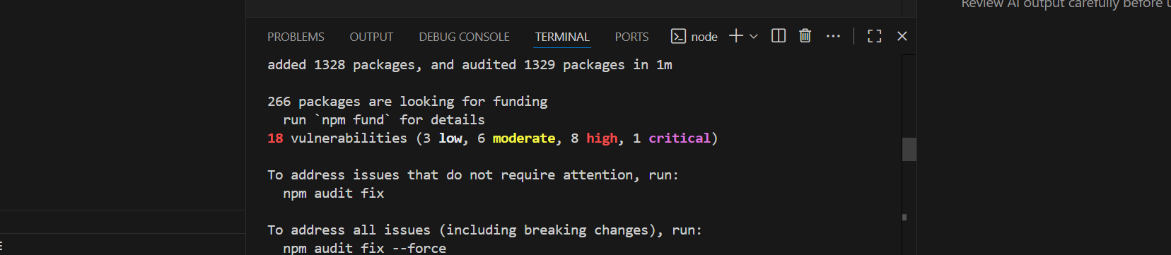

**Step 2:** Type npm start and press enter

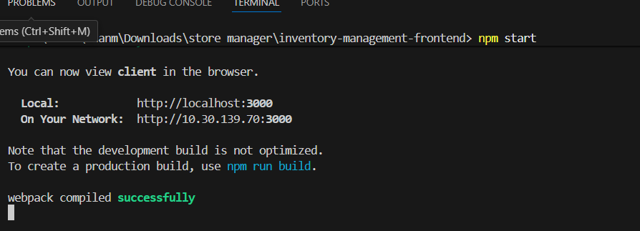

Step 3: Project will run in localhost:3000

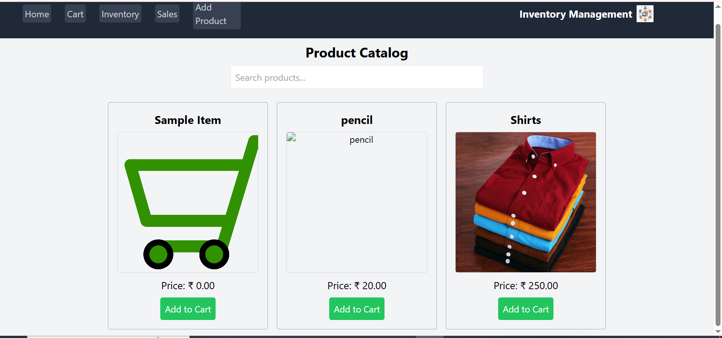

Step 4: Go to inventory for adding the product details and stock

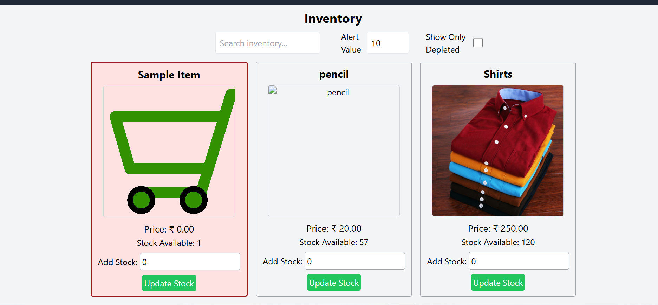

Step 5 : Go to sales to check the sales Record and go to

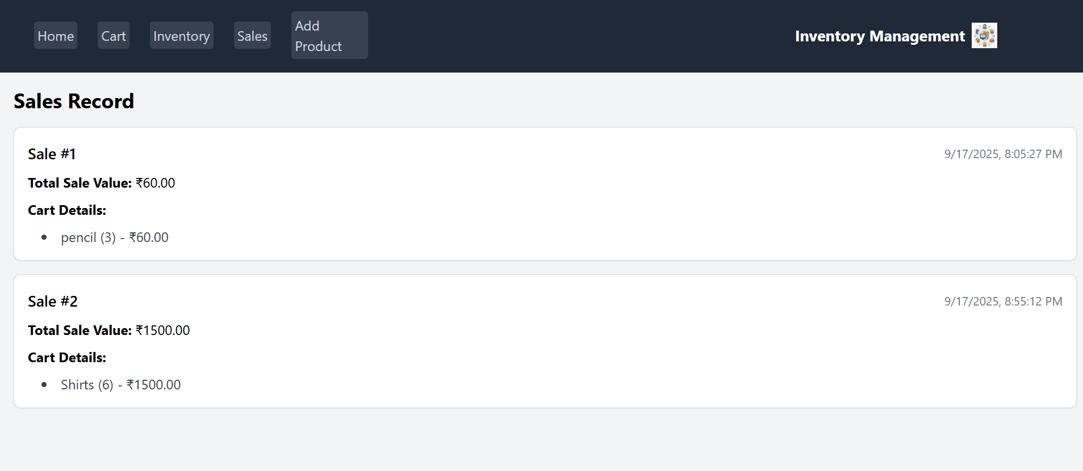

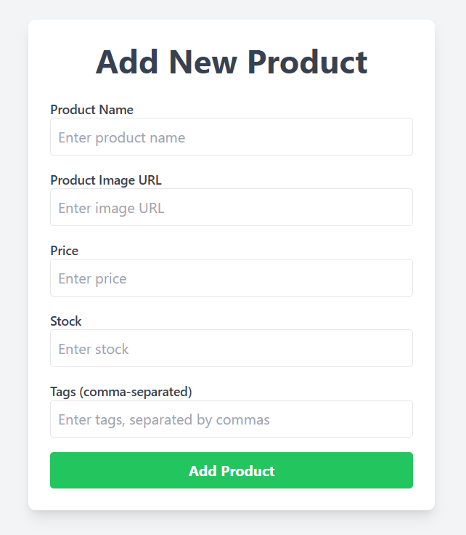

**12. Known Issues** : Nill

# 13. Future Enhancements

* **Real-Time Inventory Tracking**
* **Customizable Notifications**
* **Cloud-Based Data Backup**
* **Role-Based Access Control**
* **Offline Mode Support**